**Tushaar WeatherPy Analysis and Conclusions Report**

Based on the graphs, many trends can be observed.

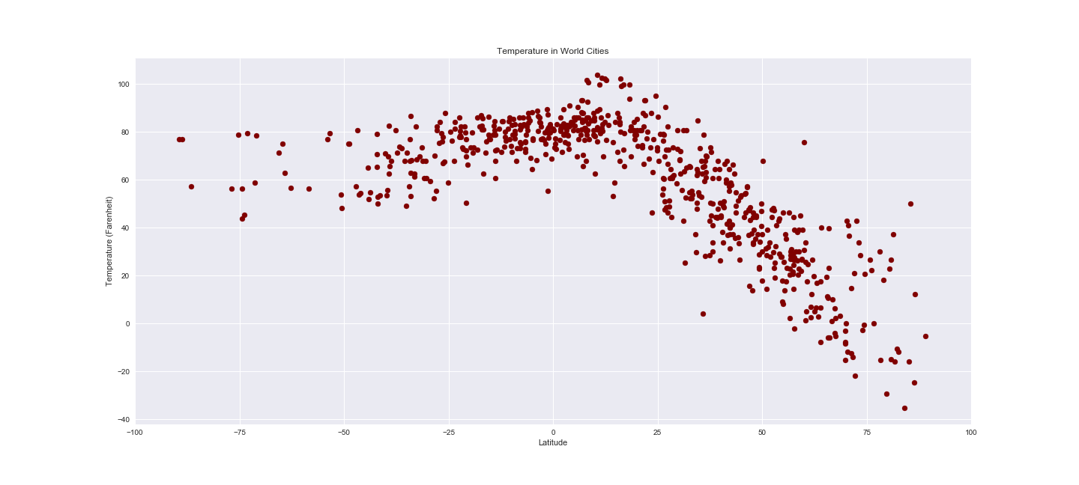

**Latitude Vs Temperature in World Cities**

1. As we go closer to the equator, the temperature rises and as we go up the north pole, the temperature rapidly stars falling down.
2. At around 80-90 degrees latitude, the temperature goes to less than -30F!
3. On the left half of the graph, you will see the temperature are still generally warm, even though the distance from the equator is increasing. This is because in the month of March we are still in ‘late winter/early spring’ for the northern hemisphere, which means we are still in summer for the southern hemisphere
4. If we plot this exact same chart in July or August of this year, we will see that left half of the graph will be touching negative temperatures, because that will be winter for the southern hemisphere (and summer for our norther hemisphere).

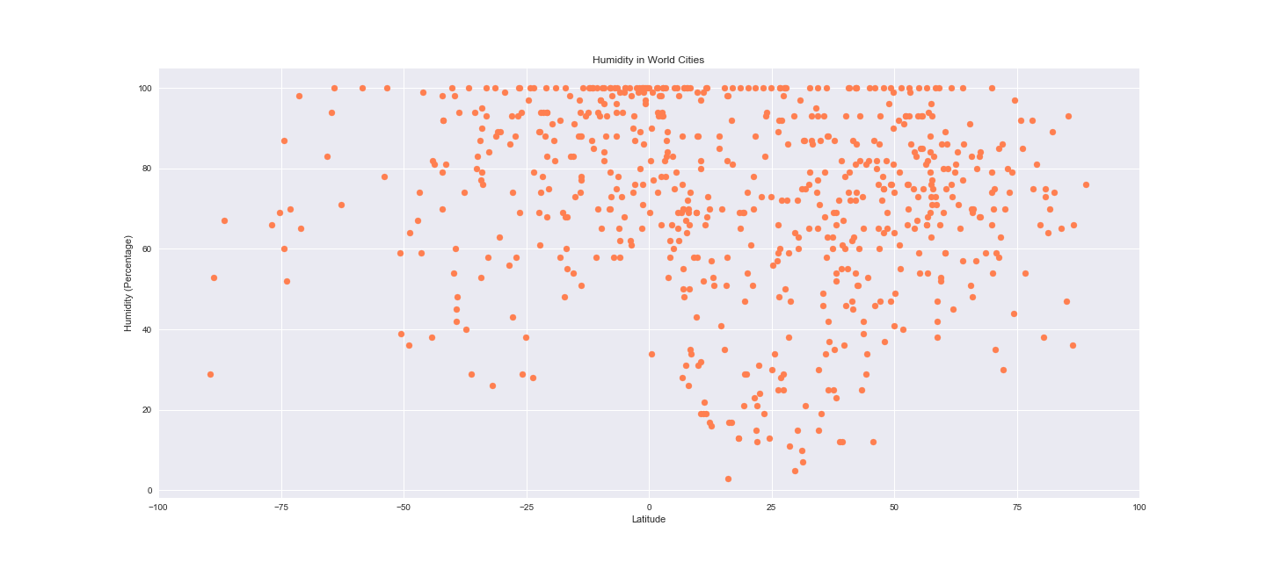

**Latitude Vs Humidity in World Cities**

1. This plot is not very conclusive. This is because the pattern of humidity is not tied to the latitudes.
2. You will see that most of the cities that are in equator are generally humid, but you will also see humid cities at varied ranges of our latitudes. This is because humidity is also controlled by the natural flora and water (costal locations) of each city. The cities that are close to large bodies of water (large lakes, large rivers, seas or oceans) are normally more humid.

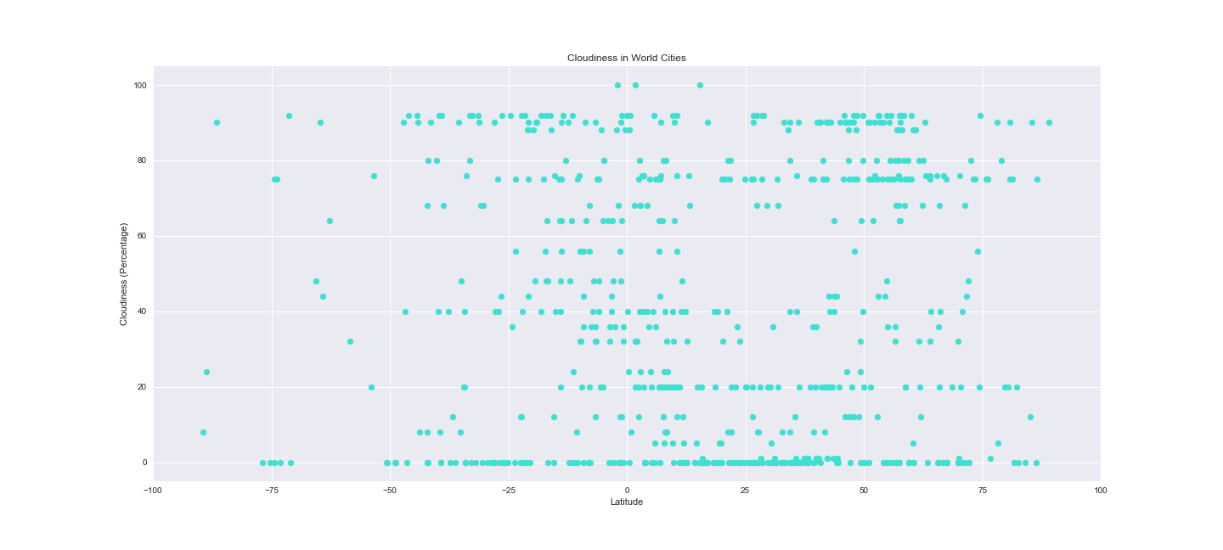

**Latitude Vs Cloudiness in World Cities**

1. Unfortunately, this plot is not very conclusive either. This is because the pattern of cloudiness is not directly tied to the latitudes.
2. You will see that cities have varied weather patterns for their cloudiness all over our plot regardless of their corresponding latitudes. This means that clouds in general can be formed due to various reasons – precipitation, rainfall, flora/fauna, winds, humidity etc. in each city, regardless of which latitude the city falls in.

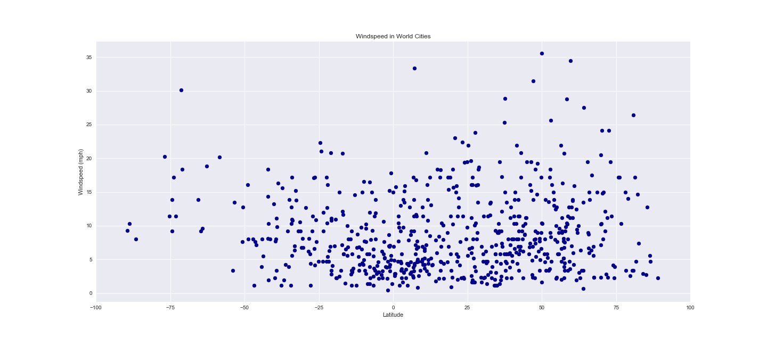

**Latitude Vs Wind speed in World Cities**

1. Again, this chart does not show us any direct correlation of a city’s wind speed to its corresponding latitude.
2. If you look at the chart closely, you will see that a *somewhat* heavy concentration of cities close to equator normally are not that windy, but again this chart also shows that there are many cities near equator which have high windows in the range of 5 – 20 mph.
3. This chart also shows us that they are many cities which have low wind speeds (less than 5 mph) at every latitude from 0 to 90, similarly there is a good number of cities that have high wind 5-25mph at varied latitudes from the equator. One outlier city (near 50-degree latitude has wind speed of 35+ mph)
4. Bottom point: Based on this data, we can again make a similar conclusion as we did in our prior 3 charts, i.e., Wind Speeds of our cities are not directly tied to their latitudes.